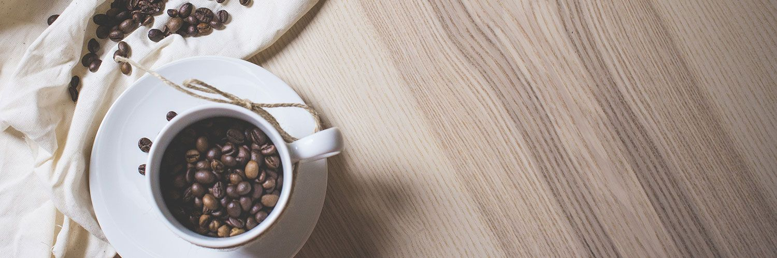

|  |
| --- |
| Montgomery  Cup |
| While we love seeing our guests and building a personal relationship with each of you. We are operating in unprecedented times.  Due to social distancing we will only be able to accept Drive thru and carry out orders.  Please know that we are taking all necessary precautions to ensure everyone’s safety and that as soon as we can return to normal we will. |

|  |
| --- |
| Free Coffee for first responders and hospital staff! |
| We want to take time to honor our first responders and those who serve the community daily.  Please just show a staff member your badge to receive your free large coffee. This offer is valid at all of our central Ohio locations.  (Limit one per customer per day) | |